Senior Health
Course Overview
2023 - 2024
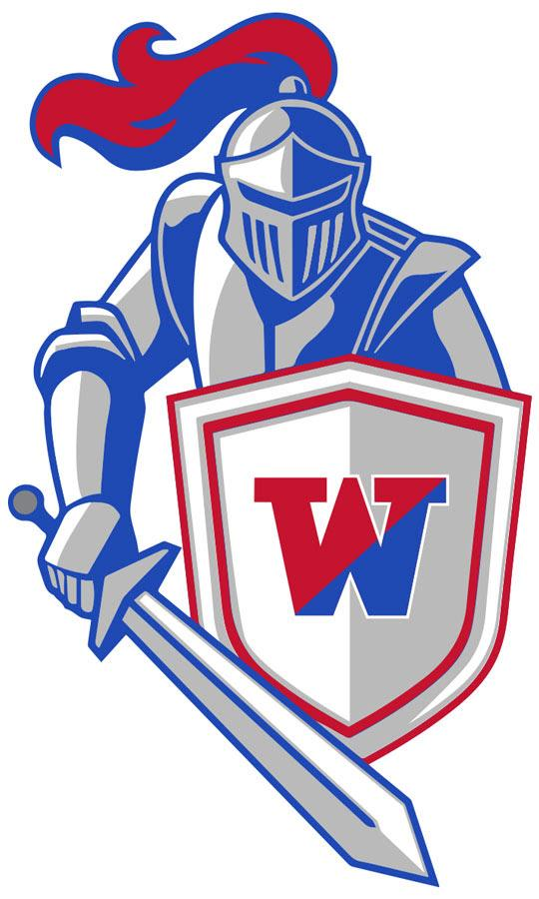
- Be on time!

- During instructional time, your cell phone is away! Please be respectful!

- If you are absent from class it is your responsibility to check with me as soon as you return and get the work that you missed. All class work and assignments will also be posted on Google Classroom, so there is no reason why you can’t keep up with your assignments.

- Be prepared with the following items:
  - Chromebook & Charger
  - Notebook
  - Pen or Pencil
  - Assignments

- Grading Categories
  - 50% - Major Assessments - Tests
  - 30% - Minor Assessments - Quizzes
  - 20% - Class Work / Participation - Daily assignments and discussions

- Topics

In response to the growing opiate epidemic, the Manchester Township Police Department has researched, developed, vetted and successfully implemented a new interactive high school opiate awareness program entitled #NotEvenOnce. Instructed by police officers, this interactive course is a collaborative effort between law enforcement and educators with the goal of informing students about the dangers of opiates before they leave for college or enter the workforce. This program, which meets all of the New Jersey Student Learning Standards for health classes, is taught to students during their senior year of high school. The ultimate goal of this program is to educate students about opiate abuse and give them the tools they need to make better decisions.

This is the 4th year that Wall Township High School and the Wall Township Police Department will be presenting this program to our 12th grade Health classes. Through meetings and emails the teachers, administrators, guidance personnel and the police officers were able to map out how and when this program would be conducted.
http://manchesterpolicenj.com/not-even-once/

  - Chapter 28 – First Aid and Emergencies
    - Lesson 1 - Providing Basic First Aid
    - Lesson 2 – CPR and First Aid for Shock and Choking Victims
    - Lesson 3 – Responding to Common Emergencies
    - Lesson 4 – Treatment for Poisonings

  - Chapter 9 – Mental & Emotional Health
    - Lesson 1 – Mental Disorders
    - Lesson 2 – Suicide Prevention
    - Lesson 3 – Getting Help
    - Lesson 4 – Understanding Death & Grief

  - Chapter 8 – Managing Stress & Anxiety
    - Lesson 1 – Effects of Stress
    - Lesson 2 – Managing Stress
    - Lesson 3 – Anxiety and Depression
    - Lesson 4 – Being Resilient

We like to have class discussions about our material. Class discussions make the material more interesting and fun. However, this does not mean that the entire class talks at once. Class discussions do not mean free time for you! Pay attention and ask questions! We encourage you to share stories about the topics we are covering. Throughout the marking period we will be discussing some adult issues. If you have a personal connection to any of the topics, and they make you uncomfortable for any reason, please try to let us know ahead of time.

